

**IEDC PROJECT REPORT**

**ON**

**“DESIGN AND DEVELOPMENT**

**OF**

**INTELLIGENT WATERING SYSTEM”**

**SUBMITTED BY:**

**Shenil Gangrade (ME)**

**Mohd. Asad Ansari (CS)**

**Sneh Suryvanshi (EC)**

**Vivek Mane ` (EC)**

**PROJECT MENTOR: Dr. Arvind Kumar Shrimali**

**TO**

**DEPARTMENT OF SCIENCE & TECHNOLOGY (DST)**



**CHAMELI DEVI GROUP OF INSTITUTIONS**

**INDORE (M.P.)**

**2018-19**

**CERTIFICATE**

This is to certify that IEDC project report “**Project Title”** issubmitted to Department of Science & Technology (DST), by **Project Team Members name.** The matter embodied is the actual work done by the **Project Team Members.**

**Forwarded By:**

**Project Mentor HOD (ME)**

**Mr. Arvind Kumar Shrimali Mr. Deepak R. Phalke**

**Prof. K. Srikant Dr. K.S. Jairaj**

Chief Co-ordinator, IEDC Dean, CDGI

**DECLARATION**

We “DR. Arvind K. Shrimali, Shenil Gangrade, Mohd. Asad Ansari, Sneh Suryavanshi, Vivek Mane”, hereby declare that the work presented in this project report entitled **“Design and Development Intelligent Watering System”** is the outcome of our own work and correct to the best of our knowledge and this work has been carried out as per the guidelines laid down by IEDC Technical Committee.

**Project Mentor & Students Name**

**Dr. Arvind K. Shrimali (Project Mentor)**

**Shenil Gangrade (ME)**

**Mohd. Asad Ansari (CS)**

**Sneh Suryvanshi (EC)**

**Vivek Mane (EC)**

**“Design and Development of Intelligent Watering System”**

**Startup Name:** Smart Agrotech Solutions pvt. ltd..

**Website address:** www.smartatech.com

**Team Detail**

Dr. Arvind K, Shrimali (Managing director)

Shenil Gangrade (Director)

Mohd. Asad Ansari (Director)

Vivek Mane (Director)

Sneh Suryvanshi (Director)

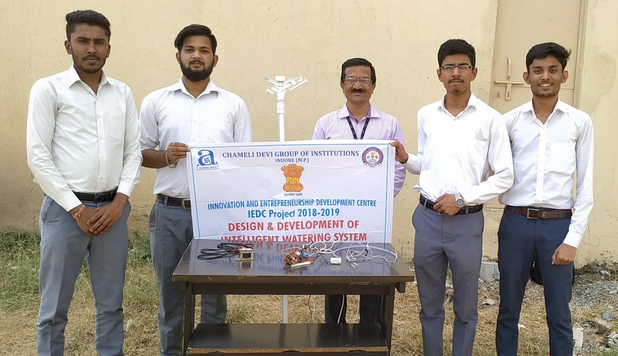

**About Company:**

Primarily this company is dedicated towards setting up of new dimensions for. It is intended to meet critical needs in agricultural sector including easy watering to crops, remote access to field, determining moisture and mineral content (later on). Further the company may expand to new horizon that may provide even better (new) techniques to irrigate crops with a very economic and handy setup. Company is dedicated over strong customer-focused approach, conformance to global standards and constant quest for top-class of products.

**About Product:**

**TABLE OF CONTENT**

|  |  |  |
| --- | --- | --- |
| **S. No.** | **Content** | **Page** |
| **1.** | Introduction of project | **6 to 6** |
| **2.** | Need for the project. | **6 to 6** |
| **3.** | Detailed features of the product | **7 to 7** |
| **4.** | Basic flow chart of the working of project | **8 to 8** |
| **5.** | Problem Definition of the product | **9 to 9** |
| **6.** | How our product aims at solving these problems | **10 to 10** |
| **7.** | Technical aspects involved in design and implementation of product | **10 to 10** |
| **8.** | Road map/ Phase wise work detail | **11 to 12** |
| **9.** | Market analysis | **13 to 13** |
| **10.** | Existing similar products in the market | **13 to 13** |
| **11.** | Comparison table of our product with existing products | **13 to 13** |
| **12.** | Cost analysis of the product | **14 to 14** |
| **13.** | Future innovations we intend to do with our project | **14 to 14** |
| **14.** | List of Prospective clients / customers | **15 to 15** |
| **15.** | Conclusion | **15 to 16** |

**INTRODUCTION**

This project aims at reducing the wastage of water while watering the fields by providing stipulated supply of water. Also it reduces the physical strain of farmer by providing remote access to the farmer via a simple user interface developed on the android. The entire system uses IOT setup that includes controlling of water supply by checking the moisture content of soil via sensors placed at roots of plant. The entire setup is very handy (portable) and can be installed without much labor or technology required. It can specially be used for places where there scarcity of water and farming is difficult because of scarcity.

**NEED FOR THE PROJECT**

The primary need for this project to avoid the wastage of water while watering the fields because watering the plants via traditional methods causes a lot of water to waste due to evaporation or flowing out the field by canals before reaching the plant roots or getting soaked by the ground below the roots of the plants.

This product is required because it is not possible for the farmers to check the moisture content at the roots of the plants thereby making it difficult for them to determine the exact amount of water required by the roots of the plant.

This product is required because in India farmers have more than one fields at a distance of 5km or even more. It is very convenient and a wastage of time too to visit each field to check whether water supply is proper or not. A solution to this problem has been provide with the help of remote access to the water supply via a simple cell-phone application.

Determination of amount of water supplied and the amount of water to be supplied can easily be measured with the help of sensors connected at the nozzle to check the water in LPM. And the user interface is also able to show the exact amount of water supplied or to be supplied as per the type of the crop.

**DETAILED FEATURES OF THIS PROJECT**

**STIPULATED SUPPY OF WATER**

Stipulated supply of water supplying correct amount of water at right place and right time. This can be easily be done with the help of this product as sensors have been installed at the supply (nozzle of sprinkler, drip, etc.) and receiving (roots of the plant) point. The mobile with the help of sensors via IOT will recognize the exact amount of water required by the crop. It can also manipulate the amount of required by depending upon the type of crop and the data obtained for the crop.

**MOISTURE CONTENT OF THE SOIL**

Moisture content of the soil can easily be determined with the help of tensiometric moisture sensors installed. As different crops require different content of moisture at the roots this product helps in providing exactly the right amount of moisture at the roots neither less nor excess. Thereby saving a lot of water in day to day irrigation practices.

**IOT SYSTEM**

The entire system is connected with wireless technology. Wi-Fi modules have been placed at the control unit to convey the on-field status to the farmers on a very user friendly mobile application. Thereby providing them remote access to their fields without any physical strain. With the help of commands on the mobile application you can control the entire setup sitting at distant from your field.

**USER INTERFACE**

User interface here is a mobile application that helps in controlling the entire through an android phone. It has been developed on android with the help of and has been given connection to the watering system with the help of Wi-Fi modules. Data of moisture content, root depth etc. has been fed for different crops in different season which helps in controlling the water supply in a better way.

**BASIC FLOW CHART OF WORKING PROJECT**

Login

Select Crop

Establishing Connection

Retry establishing connection

Establishing Connection

NO

Yes

Initiate water supply

Track the progress

Progress details via UI

NO

If Moisture requirement fulfilled

Yes

**PROBLEM DEFINITION OF THE PROJECT**

**OVERSUPPLY OF WATER**

While watering the plants with the traditional method it consumes a lot of water for the same crop as compared to our product. As while watering the fields with the traditional methods a farmer cannot identify the exact amount water or moisture required by the roots of the plants as a result most of the water gets evaporated due the evaporation or run out of the fields without getting soaked or get soaked inside the field up to an extra depth.

**DIFFICULTY IN DETERMINING MOISTURE CONTENT**

In this case farmers cannot detect the exact amount of water require the crop and hence cannot determine whether they have sufficient water left or not. They are not able to determine the how much water has been supplied or how much water is left to be supplied?

**FREQUENCY OF VISITS AT THE FIELD**

Farmers have more than one fields at distant place so they need to visit each field at regular time intervals in a day to check whether the water is proper or not. It consumes a lot of time and physical strain because fields may be located at distance from one another.

**NO REMOTE ACCESS**

No remote control is present for the farmers to control water supply at the field without being physically present at the field. It causes a waste of money in travelling and physical strain too because it is quite difficult for the farmer to be present every time at the field while watering the crops.

**SOLUTIONS TO THESE PROBLEMS**

The solutions to above stated problems are given as –

1. Oversupply of water can be controlled by providing stipulated supply of water (at right place at right time in right quantity). This can be done by checking the exact amount of water require by the crop during various phases of its development which can be determined by the moisture content required by the soil. …………………………………………………………………………………………………..
2. Remote access of the control unit (comprising of PCB board, Wi-Fi module, nozzle arrangement, etc.) can be controlled by a simple user interface developed for the android which helps reducing wastage of time and physical strain of a farmer to a greater extent.
3. Amount of water that has been supplied can be easily determined with the help of sensors fixed at the nozzle which ion LPM. Also the amount of water required to be supplied can be determine by feeding data of water requirement by various crops at different phases of growth i.e. farmer just need to select the type of crop and stage of growth to get exact details of water supply.

**TECHNICAL ASPECTS INVOVEL DESIGN AND IMPLEMENTATION OF PRODUCT**

**SENSORS:** To check moisture content of the soil

**IOT:** Completely automatic system to communicate status.

**INSTALLATION:** Easy and robust installation with no use of heavy machinery

**SOFTWARE:** Remote access to every details on field via android.

**EASY REPAIR:** No need to disturb entire setup if a sensor unit malfunctions.

**ROAD MAP**

1. **REQUIRMENT GATHERING**

In this fast growing and less caring world. One of biggest problem is water supply. With growing technology the agriculture sector is getting loads of benefits. On the other hand farmers are facing a problem of water shortage. They generally leave the water pumps on and leave the field. Which in turn results in wastage or oversupply of water, sometimes it may result in undersupply. Which will result in decrement of crop quality. So we came up with an idea to make an intelligent system which will keep track of water supply and gets the water supply automatically started and stopped while notifying the farmer.

1. **DESIGN**

So on basis of above analysis, we designed an Intelligent watering system which will keep track of water supplied in the field and will give proper amount of water required for a particular crop.

At first we selected a water supplying system as we were making water system intelligent not creating a completely new one? So we selected Sprinkler system as water supplied can be easily tracked in it.

Next, we used selected moisture sensor which will check whether enough supply of water is done to a particular crop or not. As we selected the sensor now we found new sensors which will turn the water pump on or off on giving signal. So we used sensor.

Now we need to design a communication media through which moisture sensor can communicate to motor sensor to turn on/off motor. So we prepared a robust design of wires which will connect the moisture sensor to motor sensor.

Another problem is we need multiple sensor in a field as not every part of field will get irrigated equally, so to keep track of field we need multiple sensors which can communicate with each other intelligently for water supply. A Robust communication design is also ready for that.  
At last we prepared a User Interface through which user can keep track of the field easily from anywhere and anytime.

Another important required thing is data of how much water needs to be supplied to each crop, this data is to be generated from testing.

1. **Implementation**

We started to make this project by first working on sensors. At first we find out which sensors best fits our requirements. On basis of various searching we used Moisture sensor…… for checking water level or moisture content in the soil. And for turning motor on and off we created a micro controller system for this purpose. We designed a PCB for our microcontroller which has transistor, capacitor, etc.

Then we worked on the communication system we created a robust arrangement for that. This arrangement design was working successful but on implementing it on a field we found out that the communication media got harmed or disturbed by activities of farmers. So we used pipes to protect our wired system. Which was pretty cheap and better for our system.

Then we programmed the sensors and so that they can communicate with each other along with basic working like starting and shutting off the system.

One of last stage is to create a user interface for the user so that they can access the system easily from anywhere around the world. So we created an interactive, creative and catchy UI for the system.

1. **Testing**

On testing at first our Communication system failed on a field where farmers generally work, so we used pipes to protect our system from activities of farmer.

The Sensor and micro controller worked pretty well, and doesn’t required changes.

Then we worked with the communication system which become cheap and perfect for our system.

Later we tested the system for various crops to check how much water supply is required for each crop, as all crops don’t need same amount of water. So we, prepared a dataset of water requirements for each crop. So that the user just need to select the crop and our system intelligently tracks the water supply.

Next thing was to work on User interface. As we tried to use the UI via internet there remain some issues but all the bugs were fixed. And now our system can connect with the user easily although we haven’t published our system on internet.

**MARKET SURVEY**

This product saves a lot of water while irrigation which is the biggest need of today so this product can be used where there is scarcity of water and water efficient crops cannot be grown.

Crop quality will be better as much things have been researched on the moisture content required by the soil.

It also reduces human effort or extra physical strain which is the most demanded thing of today’s era. Hence with the help automation provided in this extent human working can be made efficient up to much extent.

This product in very easy to use and requires no heavy machinery for the installation which sseems very economic and also saves time.

In short this entire project is focused on saving time, money and efforts hence making the entire working much more efficient.

**LIST OF EXISTING PRODUCTS IN THE MARKET**

Drip and Sprinklers are available for the regular supply of water.

Traditional methods are watering the fields by constructing canals.

Nozzles are there (of drips and sprinklers) which cannot check the amount of water supplied (for example in LPM or any other method).

No water supply system can be operated without physical presence i.e. no water supply system can be operated with the help of any software or wi-fi module.

**COMPARISON OF OUR PRODUCT WITH EXISTING PRODUCTS**

No such standard product is readily available in the market.

Drips and sprinklers can’t check the moisture content of the soil.

Drips and sprinklers are unable to check the amount of water supplied.

No standard mobile application is available for the remote access.

**COST ANALYSIS**

|  |  |  |  |
| --- | --- | --- | --- |
| **Synod** | **Date** | **Components** | **Bill Amount**  **(In INR)** |
| 1 | 14/2/2019 | Electronic Components (moisture sensor, relay, etc.) | 2395 |
| 2 | 15/2/2019 | Pipes (CPVC 1”) | 767 |
| 3 | 15/2/2019 | Pipes with couplers(CPVC coupler and elbow) | 478 |
| 4 | 15/2/2019 | Sprinkler set with arrangement | 2200 |
| 5 | 16/2/2019 | Nut bolt, wire, Teflon tape etc. | 650 |
| 5 | 26/2/2019 | Razor blade, screws, hinges etc. | 385 |
| 6 | 27/2/2019 | Electronic components (ICs, Power supply, etc.) | 1520 |
| 7 | 28/02/2019 | Water sprinkler set | 2200 |
| **In Word: Rupees Ten thousand nine hundred and ninety five** | | | **10,595** |

**FUTURE WORKS**

We planned many new features for our system so that it remain as a tycoon in industry:-

1. We will publish our system on web.
2. By taking feedback we will improvise and make the water requirement calculations better with time.
3. We will try to work on water supply and geographic relations of agriculture.
4. We will introduce the water supply tracker which will show how much moisture or water supply, is done in field.
5. The system will show estimated time for the system each day.
6. With some drones we will use image processing to check the quality of crop.
7. We will introduce soil sensors which will give the user details of soil in field.
8. And will also show which crop would be best for planting on field on basis of soil and whether information.

**LIST OF PESRPECTIVE CLIENTS**

|  |  |  |  |
| --- | --- | --- | --- |
| **Synod.** | **Name** | **Address** | **Contact No.** |
| 1. | Sh. Ashok Malaya |  |  |
| 2. | Raja ram Thakur |  |  |
| 3. | Mohit Jat |  |  |
| 4. | S |  |  |
|  |  |  |  |
|  |  |  |  |
|  |  |  |  |
|  |  |  |  |
|  |  |  |  |
|  |  |  |  |
|  |  |  |  |

**CONCLUSION**

Now conclusion and future scope is the last mile stone of our project, in this project we done a lot of work to make this project and we enjoy the journey of this project and we think differently from the others and make this project. During this project we learns lots of practical knowledge. In this project we apply a lots of our theoretical knowledge and we learn lots of thins during this project. And the most important thing how to manage the project and we know the fact that this project experience is more advantageous for us in future ahead. So let’s take some glimpse of the intelligent watering system project journey.

In the first step we identified the problem related to the pet animals

Then we brainstorms all the possible solution.

And then finally we select the one solution.

Then we make a literature survey on the project.

And then we makes a methodology of this project.

Then we made a design and analysis by the solid works software.

Then we are going for material procurement process.

After material procurement we are going for fabrication.

After fabrication we got our final product.

And then we tested our product lots of time.

After testing process we makes a result and discussion on this project.

And after result and discussions we decided its future scope.